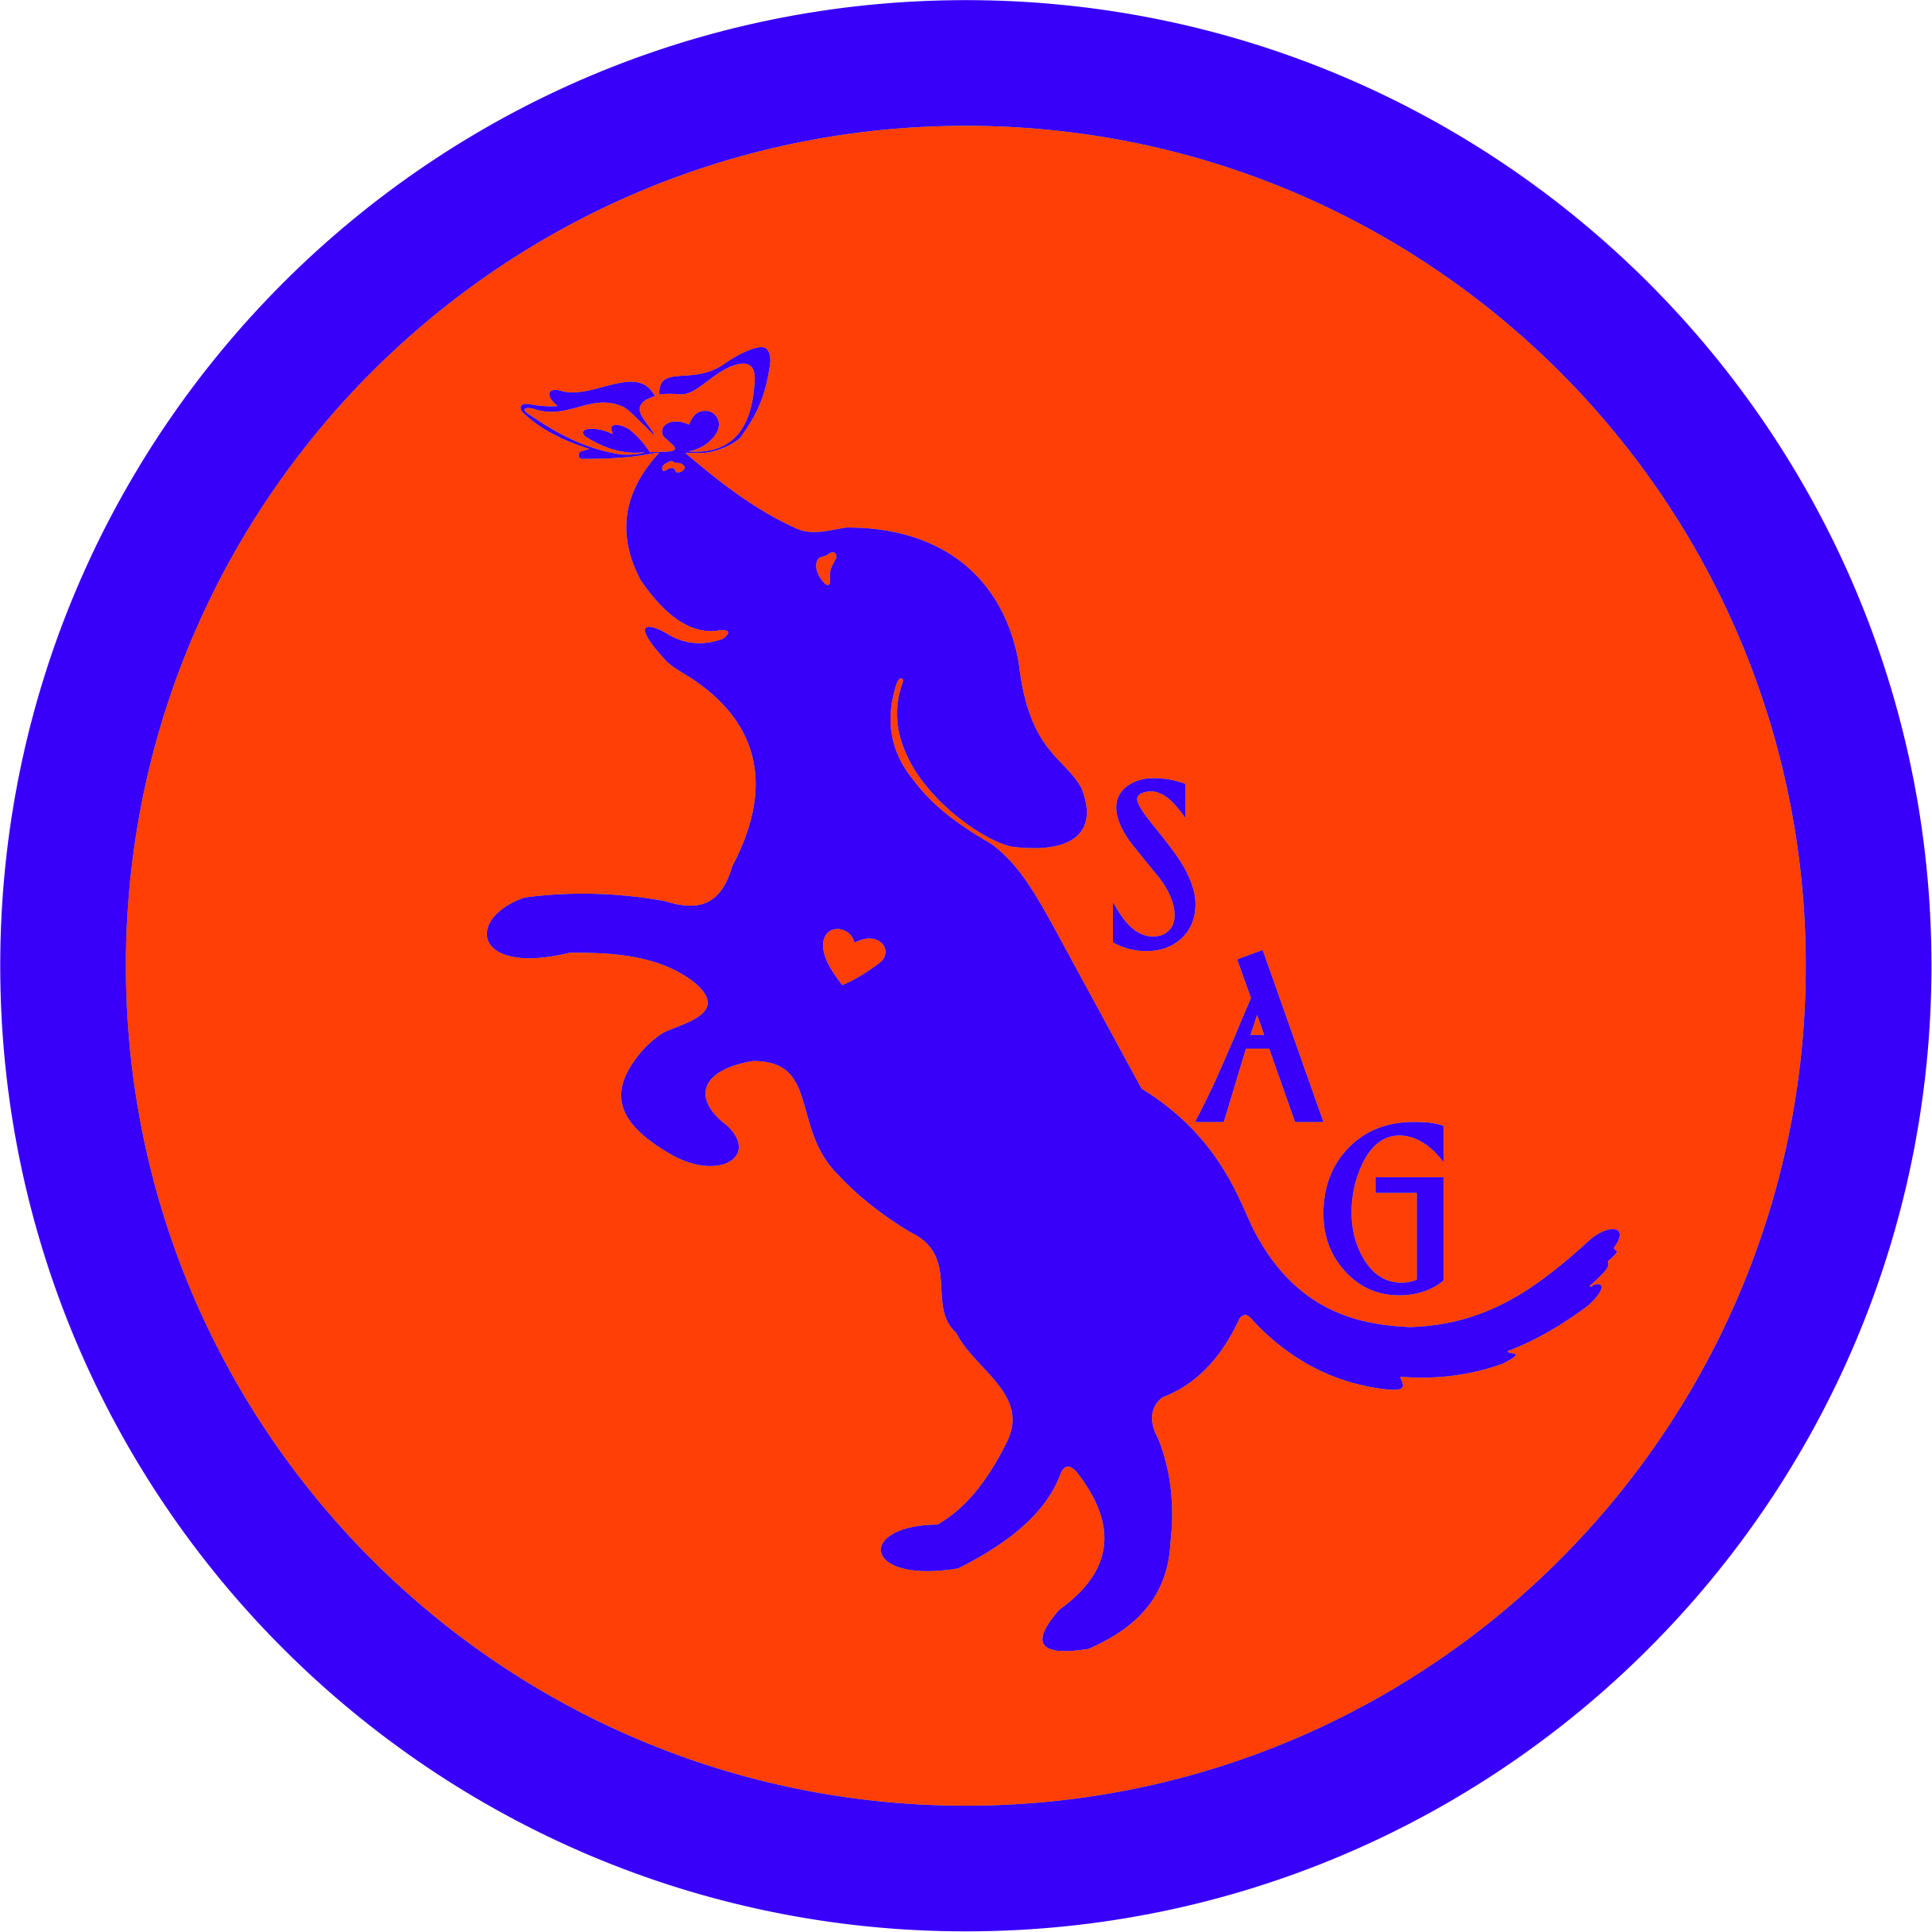

SchaSam Agility Group  14 & 15 November 2020  Fun Fur Paws Arena  22352 Stargate Place  Mount Vernon WA 98274  Judge:  Patti Cavin  Double run format  Indoors on dirt, one 80x100 ring  Rubber Contact Surface – no slats  Crating will be in your vehicle. No indoor crating. You may arrive at the arena Saturday and Sunday after 7am.  General briefing will be emailed to you with your confirmation. Read it for any changes due to COVID.  First dog on the line at 8:30 am both days | Preliminary Class Order:  May change depending on weather, judge’s preference, time or number of entries  Saturday  Class: Double Run Single Run  Chances 2  Touch & Go 2  Gamblers 2  Barrelers 2  Sunday  Class: Double Run Single Run  Weavers 2  Tunnelers 2  Hoopers 2  We are holding this trial strictly within the requirements for COVID Agricultural Events and within the current phase for Skagit County. If you cannot/won’t wear a CLOTH mask at all times while in the building or when not social distancing, please do NOT enter this trial. Anyone who cannot/will not follow the requirements will be asked to leave the trial and no refund will be given.  We will gladly refund your entry for runs not taken if you feel sick while at the trial. If you were exposed to someone who tested positive or have a reason you cannot be around people please let us know before the closing date so we can refund your entire entry. Anything after the closing date, please coordinate with the Trial Chair.
Entries Open Immediately  Entries Close on 10 November  Crating available in your vehicle  Entry Limits: 250 runs per day  Move ups can be made day to day but not same day  Day of Show Entries cannot be honored due to COVID requirements  Refunds: Full refunds will be issued for COVID concerns (feel sick at the trial, have COVID 19 symptoms, have been exposed to someone with COVID within 14 days of the trial, if you tested positive for COVID within 14 days of the trial or have a recently diagnosed reason that you cannot be around people), BIS or injury to handler or dog which precludes trialing.  Containerized Trial: This is a containerized trial. All treats and toys must be containerized (zip lock bag or other sealed container) with the following exception: NADAC allows a handler to carry a toy (non-noise making) in the ring in a Novice or Introduction run. The handler must “declare” the toy to the judge before starting the run (wave it in the air, getting the judge’s attention).  Leash Running: Under COVID 19, you may elect to carry your leash with you during your run to preclude the leash handler from having to move your leash. The leash must be in your pocket or otherwise secured BEFORE your dog starts his/her run.  Equipment Info: All equipment meets NADAC standards. The A frame & Dog Walk have rubber surfaces; no slats. Weave poles have 24” spacing. | Show Committee  Trial Chair Sam Lietz (SchaSamFarm@yahoo.com)  Trial Secretary Beth Gideon (dogfish6@comcast.net)  Chief Course Builder Kari Hammagren  Asst Course Builder James Hopper  Volunteer Appreciation Kathy Swan  Hospitality Lizzy Buller  Photographers Meagan Spitler & Lynn Allen  Confirmations and additional information will be sent by 11 November 2020  Food info: Due to COVID restrictions, no food or drinks will be made available. There are numerous food opportunities at the facility exit from I5 (espresso, tacqueria, convenience stores) seven minutes from the arena. Please bring food and drink for you and your dog(s).  Volunteer info:  Please let us know if you will volunteer for a job on your entry. SAG will provide a random draw of worker coupons in the amount of $1, $2, $5, $10 or $20 off the next SAG event. Kathy will be drawing these for you whenever you work and will provide your envelope of coupons to you at the end of the trial.  Awards and Ribbons:  - 4th place ribbons for each jump height for all classes and levels except Chances  - New Title, 1st Qualifying Run in NADAC, NATCH, VNATCH, and AANATCH ribbons for your awesome accomplishments.  - High in Trial awards (points based) will be presented before the last class on Sunday in Intro, Novice, Open, Elite, and Senior (over 70) and Junior (under 17).  - SchaSam Farm is sponsoring a separate Jr Handler Excellence award based on sportsmanship, volunteerism and dog relationship
Jump Height Info:
MEASURING: Measurement forms may be obtained at:
https://www.nadac.com/WPsite/wp-content/uploads/2019/06/HeightCardForm.pdf
Dogs which require measuring:
Dogs in the Proficient Category, Novice, Open or Elite jumping 4”, 8”, 12” or 16”

Dogs which do not need to be measured:
Dogs jumping 16” in the Veteran or Junior Handler Division
Dogs jumping 20”
Dogs in the Skilled Category
Dogs with a permanent height card
Dogs listed on the Height Exemption List
JUMP HEIGHTS
There are four Standard Division-Proficient jump heights: 8”, 12”, 16”, and 20”.
There are four Standard Division-Skilled jump heights: 4”, 8”, 12”, and 16”.
There are four jump heights for the Veterans and Junior Handler divisions: 4”, 8”, 12”, and 16”.
Please see the NADAC Rulebook for the full jump height table

Brief Summary of Rules:
Please refer to www.nadac.com for a full explanation of all NADAC rules and up to date information.

- Please note that NADAC trials should provide a safe and fun environment for both exhibitors and their dogs.
- Aggressive dogs will not be tolerated and will be excused from the trial.
- The show committee has the right to refuse any entry. Anyone not currently in good standing with NADAC will not be allowed to enter this trial.
- Exhibitors, through submission of entry, acknowledge that they are knowledgeable of NADAC rules and regulations, and agree to abide by all rules in effect at the time of this trial.
- No entry fee will be refunded if the trial cannot open or be completed by reasons of riots, civil disturbances, fire, acts of God, public emergency, an act of a public enemy, or any other cause beyond the control of the organizing committee.
- Checks not honored by the bank do not constitute a valid entry fee. There will be a $25.00 service charge for bank returned checks.
- Dog must be registered and have a valid registration number before entries will be accepted. http://nadac.com/afrm/dogregfrm.asp A copy of the current Exhibitors Handbook may be downloaded free from the NADAC web site: www.nadac.com
- Bitches in heat, lame, or blind dogs are ineligible for entry, as is any dog with a deformity which may cause a judge to not be able to reasonably assess the dog’s ability to function and perform agility obstacles safely, and in a manner that is in the best interest, health and welfare of the dog.
- Only Intro and Novice handlers my bring a non-audible toy into the ring for training purposes. They cannot earn a Qualifying score and must declare to the judge they are training before they commence their run. No food, clickers, or other aids or devices shall be permitted on the course or within 10 feet of the ring. Food or a small non-audible toy can be in a secure container (ziplock bag is acceptable) in your pocket during your run but it cannot be used during your run, nor can you indicate to the dog it is there. Please read the Exhibitor’s Handbook for more information about toys and training in the ring.
- The sponsoring clubs will not be responsible for the loss or damage to any dog exhibited, or for the possessions of any exhibitor whether the result be accident or other cause. It is distinctly understood that every dog at this event is in the care and control of his owner or handler during the entire time the dog is on the show premises.

SchaSam Agility Group’s FIRST NADAC TRIAL, 14-15 November 2020 at Fun Fur Paws Arena, 22352 Stargate Place, Mt Vernon WA 98274 Checks Payable to: SchaSam Agility Group
Send entries and signed waivers to Beth Gideon, 720 222nd Place NE, Sammamish WA 98074
Owner |  |  |  |  | Dog
Name |  |  |  |  | Call Name
Address |  |  |  |  | NADAC Reg #
City/State/Zip |  |  |  |  | Date of Birth
Phone |  |  |  |  | Height at Withers
Email |  |  |  |  | Breed
Handler, If not owner |  |  |  |  | Emergency Contact Name/Phone
PLEASE INCLUDE A COPY OF YOUR DOG’S HEIGHT CARD IF YOU DO NOT HAVE ONE ON FILE.
CATEGORY: PROFICIENT SKILLED
DIVISION: STANDARD VET DOG VET HANDLER JUNIOR HANDLER
I WANT MY DOG TO JUMP: 4 8 12 16 20
Class | Level |  |  |  | Day
 | Intro | Novice | Open | Elite |  | Saturday | Sunday
Chances |  |  |  |  |  | Rd 1 Rd 2
Touch n Go |  |  |  |  |  | Rd 1 Rd 2
Gamblers |  |  |  |  |  | Rd 1 Rd 2
Barrelers |  |  |  |  |  | Rd 1 Rd 2
Weavers |  |  |  |  |  |  | Rd 1 Rd 2
Tunnelers |  |  |  |  |  |  | Rd 1 Rd 2
Hoopers |  |  |  |  |  |  | Rd 1 Rd 2
In consideration of the acceptance of this entry, I/we certify that I/we have knowledge of, and are familiar with, and agree to abide by, the Rules and Regulations of NADAC in effect at the time of this trial, and by any additional rules and regulations as approved by NADAC for this trial. I/we certify that the dog entered is not a hazard to persons or other dogs. I/we further agree to be bound by the “Agreement” printed on page 5 of this premium
Number of Total Runs Entered (all dogs per household): # ___________
SAG members & honorary members will receive a $1 coupon for future trials for each run entered

1-6 runs $13 each $___________
8-12 runs $12 each $___________
13 runs $10 each $___________
After closing but before 13 November = $15 per run $__________
Jr Handler (17 or less) and Sr Handler (70+) all runs $5 each $___________

TOTAL ENCLOSED =$___________
Owner/Exhibitor: ____________________________________Date______________________
Parent or Legal Guardian of Junior Handler_________________________________________

AGREEMENT – Sign and return with Entry Form
The person who signs this agreement represents that he/she is authorized to enter into this agreement on
behalf of both exhibitor and the owner of entered dog. In consideration of acceptance of this entry:
1.1. As used here "NADAC" means the North American Dog Agility Council, LLC., its members, officers, directors, employees, show chairs, show committees and agents.
1.2. Exhibitor/owner agree to abide by the rules and regulations of NADAC and any other rules and
regulations appearing in the premium for this event.
1.3. Exhibitor/owner certify that the entered dog is not a hazard to persons, dogs or property and that
the entered dog's rabies vaccination is current in accordance with the requirement of the state in which the dog resides.
1.4. Exhibitor/owner acknowledge all hazards presented by the event and the event premises,
including, but not limited to, the condition of the surface, restrooms, security measures or lack of,
electrical appliances, fittings, show rings, parking areas and the presence of unfamiliar animals and
people; exhibitor and owner assume the risk of any harm arising from these.
1.5. Exhibitor/owner releases NADAC (including its respective officers, directors, employees, and
members), SchaSam Agility Group (including its officers, directors, members, and event organizing
committee), and Fun Fur Paws (including its officers, agents, and employees) and will
defend them and hold them harmless from all present and future loss, injury, damage, claims, demands
and liabilities involving the entered dog, the event or event premises. Without limiting the generality of the
foregoing hold harmless provisions, exhibitor/owner hereby specifically assumes sole responsibility for
and agrees to indemnify and save the aforementioned parties harmless from any and all loss and
expenses (including legal fees) by reason of the liability imposed by law upon any of the aforementioned
parties for damages because of bodily injuries, including death, at any time in consequence of my (our)
participation in this event, howsoever such injury or death may be caused and whether or not the same
may have been caused or may have been alleged to have been caused by negligence of the
aforementioned parties or any of their employees or agents or any other persons

Printed Name of Competitor and Date_____________________________________________________+

Competitor’s Signature (or parent/guardian if competitor is minor child) __________________________

_____________________________________________________________________________________
Let’s fill the volunteer worker board before the trial!!! The more jobs filled the less stress of finding folks to work (especially since we cannot be hanging out in the arena….). The worker board will be outside the entry door to the building.

Please let us know day, course, level and job you are willing to perform: (i.e. Saturday, Chances Open Scribe). Just write it on the bottom of this form and send it with your entry.

Reminder Saturday Chances, Touch & Go, and Barrelers have Elite, Open, Novice & Intro. Gamblers has Elite, Open and Novice (no Intro)
Sunday has all four levels of Weavers, Tunnelers & Hoopers.

We will need a scribe, timer and leash runner for each class and level as well as minimal ring crew for all classes. Remember each time you work Kathy Swan will be drawing a $$ coupon for you!

Sign & return with entry:
Assumption of the Risk and Waiver of Liability Relating to
Coronavirus/COVID-19
The novel coronavirus, COVID -19, has been declared a worldwide pandemic by the World Health Organization (WHO). COVID-19 is EXTREMELY contagious and is believed to spread mainly from person to person contact. As a result, federal, state & local governments and federal and state health agencies recommend social distancing and in many locations, have prohibited the congregation of large groups of people.~ May 2020
Fun Fur Paws LLC (FFP) has put in place some new protocols & guidelines/preventative measures to help reduce the spread of COVID-19 at the FFP facility ; however , FFP CANNOT guarantee that you will not become exposed to, or infected with COVID-19. Further, attending classes/lessons, open practices, play days, any events, dog-related activities or exercising your dog on & in FFP property could increase your risk of contracting COVID-19.
By signing this agreement, I acknowledge the contagious nature of COVID-19 and voluntarily assume the risk that I may be exposed to, or infected by COVID-19 by attending dog related, or any activities at FFP and that such exposure or infection may result in personal injury, illness, permanent disability, or death. I understand that the risk of becoming exposed to, or infected by COVID- 19 at FFP may result from the actions, omissions, or negligence of myself and others, including but not limited to FFP, trainers, instructors, assistant instructors, members, directors, governors, agents, event secretary, event-giving club, AKC, NADAC, CPE and the facility owner and any employees or volunteers of the aforementioned parties, and any “organizations approved judge”, judging at events held at FFP.
I voluntary agree to assume all of the foregoing risks and accept sole responsibility for any injury to myself ( including but not limited to; personal injury, illness, permanent disability, or death), illness, damage, loss, claim, liability, ore expense, of any kind, that I may experience or incur in connection with my attendance or participation in dog related activities held at FFP. On my behalf, I hereby release, covenant not to sue, discharge, and hold harmless the facility, FFP, its owners, Dave and Melissa Burton, instructors/ teachers, or instructors/teachers assistants, an event giving club, their members, directors, governors, agents, event secretary, any employees or volunteers of the aforementioned parties., and any AKC (American Kennel Club), NADAC (North American Dog Agility Council), CPE (Canine Performance Events) approved judge, judging @ events, of and from the claims, including all liabilities, claims actions, damages, costs or expenses of any kind arising out of or relating thereto. I understand and agree that this release includes any claims based on the actions, omissions, or negligence of the aforementioned parties, whether a COVID-19 infection occurs before, during, or after participation in any dog related activities at FFP.
By signing this waiver, I agree to the following:
I attest to the best of my knowledge that I DO NOT have COVID-19 at the time of attending dog related activities at FFP. I also attest that I have not knowingly been in contact with or exposed to any known carrier of COVD-19 within the past 21 days. I agree that I will follow all FFP protocols, city, county, and state rules and requirements to reduce any exposure and possibility of contracting or spreading the virus during my attendance at FFP.
I fully submit that FFP, and any other person(s) affiliated with dog related activities taking place on ,or at ,FFP facility are in no way liable for any present or future COVID-19 exposure incurred at any time by any person, whether in attendance or not, during our after my dog related activities at FFP.

Signature of participant or parent (if participant is under 18 yrs old)

______________________________________________________________________ Date ___________________

Printed name of participant or parent (if handler or participant is under 18 yrs old) _____________________________________

Directions & Lodging Information:

DIRECTIONS: From Interstate 5: Take exit 218 (Lake McMurray/Conway) and turn east onto Starbird Road. At the first 4 way stop sign (1 mile), turn left onto Bulson. At the intersection with Tyee Road (.7 miles), turn left to remain on Bulson. Turn right onto Stargate Place at the sign for Fun Fur Paws (.2 miles). You have arrived at 22352 Stargate Place. REMEMBER: 5mph or less on Fun Fur Paws property.

ACCOMODATIONS:

Motels (call to confirm availability and pet policy)

Best Western College Way Inn, 300 W. College Way, Mt Vernon 360-424-4287

Tulip Inn, 2200 Freeway Drive, Mt Vernon, 360-424-6069

Mt Vernon Quality Inn, 1910 Freeway Drive, Mt Vernon 360-428-4287

Additional source for hotels/motels https://www.booking.com/pet friendly/hotel

RV Overnight Camping at Fun Fur Paws

Fun Fur Paws has limited RV camping spots with electrical hookups and unlimited dry RV or tent spaces available. Bathrooms are available on site. There are NO dump station on site. If you run your generator, please use an exhaust extender and comply with the quiet hours of 9pm to 7am.

Costs are $25 per night for electric and $10 a night for dry.

Camping fees are refundable if you notify Fun Fur Paws before 13 November of the change. No refund after the trial date. Make checks payable to Fun Fur Paws and bring to the trial.

Use the form on the next page to reserve your spot for camping.

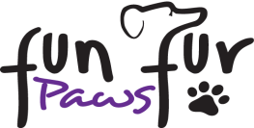
on site RV parking form (UPDATED 1-2020)
- Restroom facilities (no showers) are available: they are heated in the winter months & have running water!
- NO water hookups and no dump station on site. There is dump station at the I5 rest stop just north of Exit 206.
- Spots will not be pre-assigned; there are 19 total spots with power only (Only 1 is 30 amp, rest 50 amp).
- Quiet hours are 9pm to 7am. No GENERATORS can be run during that time.
- Respect your neighbors & please do not place exercise pens beyond your rented space.
- ALL SPOTS ARE ON GRAVEL - NO PARKING ON THE GRASS without prior authorization.

Name: ____________________________ Email_________________________ Cell phone: ______________________

Vehicle description: ___________________ Length________ Number of slide outs_______ License plate_____________

Nights you will be staying: Thursday Friday Saturday Sunday

Electric Hook Up (no sewer/water) $ 25.00 per night
Tent/ dry camping $ 10.00 per night
Make checks payable to Fun Fur Paws LLC

Total amount enclosed: ______________ Check # __________
Please mail this form & RV payment to: Fun Fur Paws, PO BOX 2176, Mount Vernon WA 98273
This fee is separate from your entry fees!!
Please Note: Camping fees are refundable if you do not attend the trial or you make plans for other accommodations. But you must let us know prior to the trial date. Once the trial starts your fees are non-refundable.
IF you wish to stay additional nights, please contact Melissa at the trial & pay any additional fees directly to her!

